# MINI PROJECT (2020-21)

**Instagram Clone**

**MID-TERM REPORT**



**Institute of Engineering & Technology**

**Submitted by-**

# Kritarth Sharma (181500335)

# Priyanka Nigam (181500509)

***Supervised***

***By: -* Mr. Amir Khan**

Technical Trainer

# Department of Computer Engineering & Applications

**Contents**

|  |  |  |  |
| --- | --- | --- | --- |
| **Abstract** | | **3** | |
| **1. Introduction** | | **4** | |
| 1.1 General Introduction to the topic | | **4** | |
| 1.2 Area of Computer Science | | **5** | |
| 1.3 Hardware and Software Requirements | | **6** | |
| **2. Problem definition** | | **7** | |
| **3. Objectives** | | **8** | |
| 4**. Implementation Details** | | **11** | |
|  | |  | |
|  | |  | |
|  | |  | |

**Abstract**

In this we will build a a dynamic project siimilar to instagram that has innovative features. We are trying to add as many features as possible.

A mobile photo(and video) capturing and sharing service, has quickly emerged as a new medium in spotlight in the recent years. It provides users an instantaneous way to capture and share their life moments with friendsthrough a series of (ﬁlter manipulated) pictures and videos.

**Features**

**1)Login User**

User can login we have used django authentication system for logging in users.Also a demo account is given for making it more useful for project purposes.

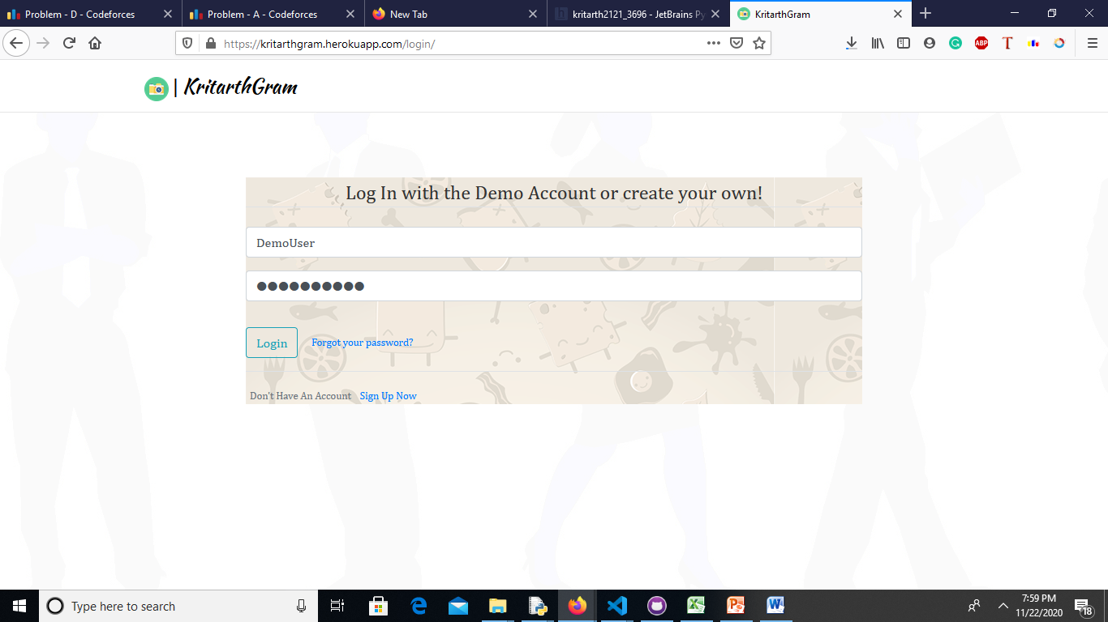

**2)Adding Posts**

Users can add post,(Upto post at a time).These post are saved in amazon s3 bucket.We have usesd AWS here.

We can also add caption for image here

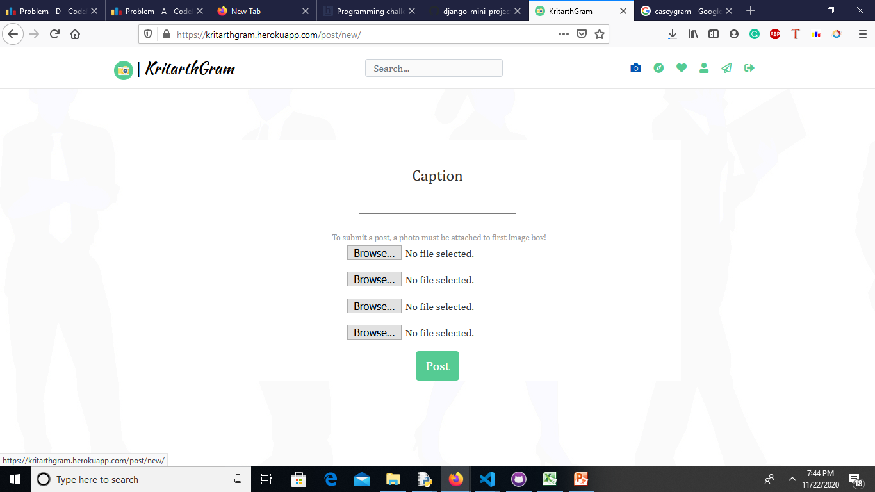

**3)Creating Account**

Users can create account by filling their credentials like desired username,emailid,password.We have used regex for password validation and username validation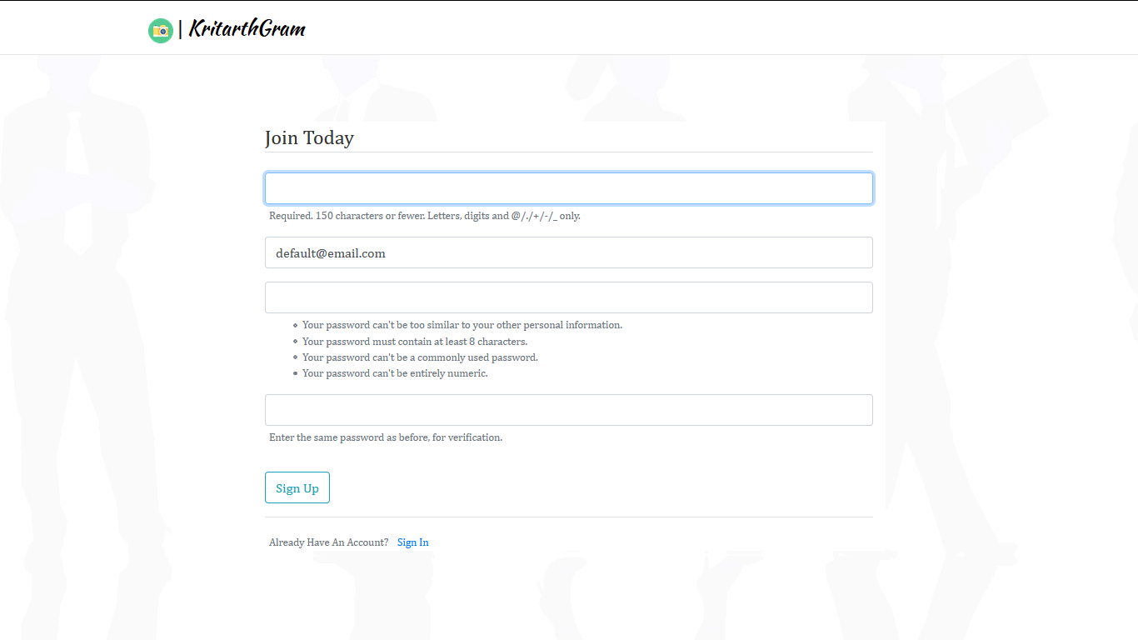

,If password doesn’t matches desired regex sequence then a, error is thrown

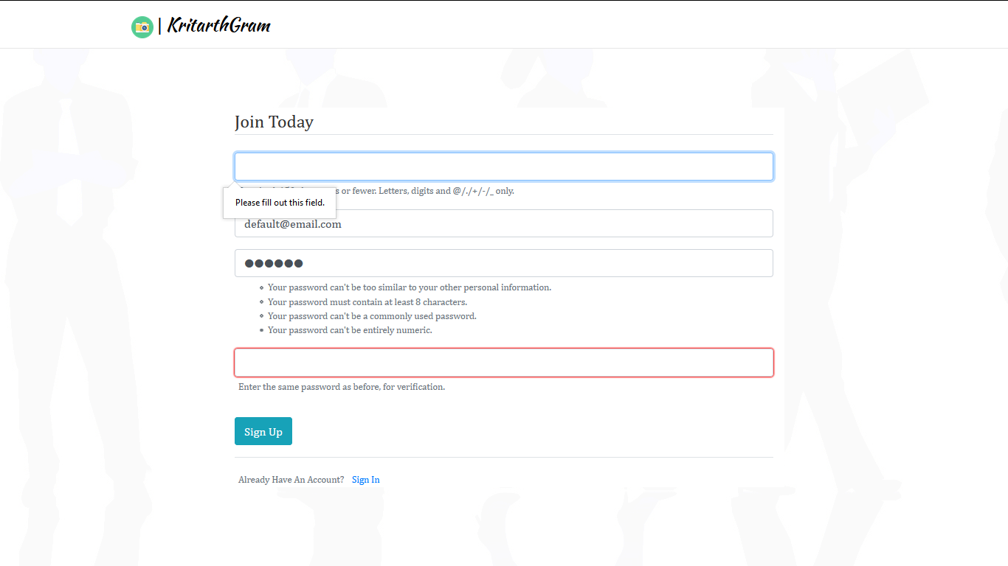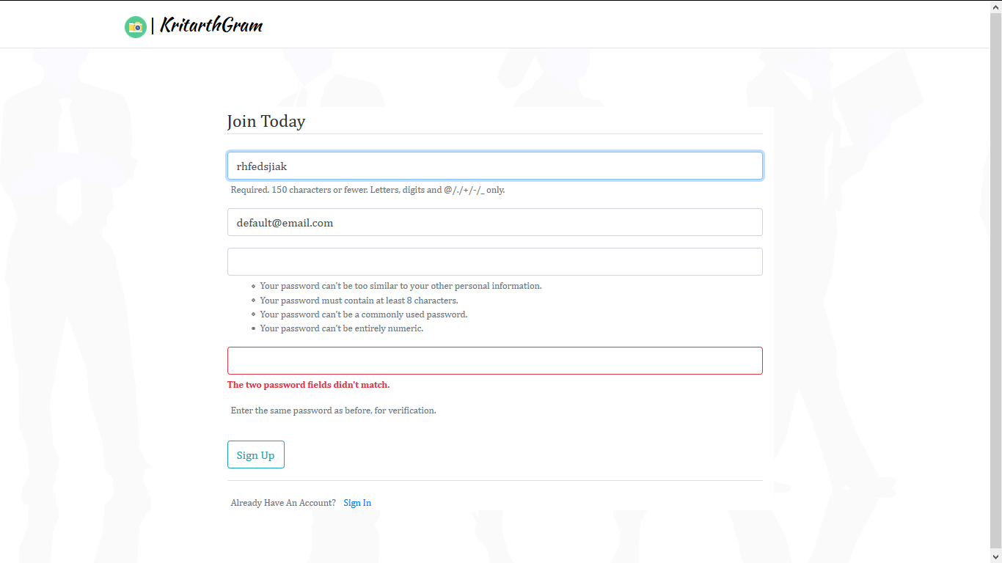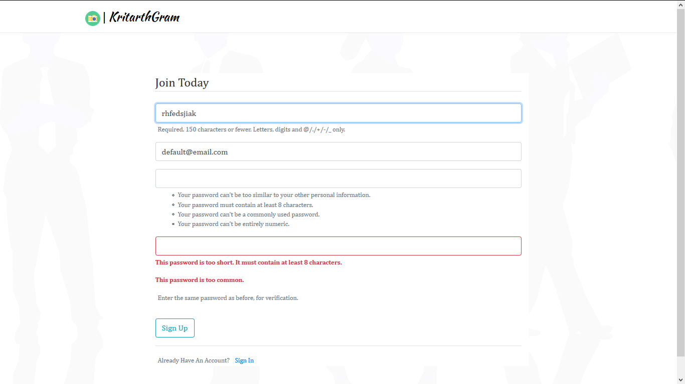

**3)Feed**

Posts are displayed along with their like count and comments.One user can like the post only once,but a user can comment multiple times on the post.

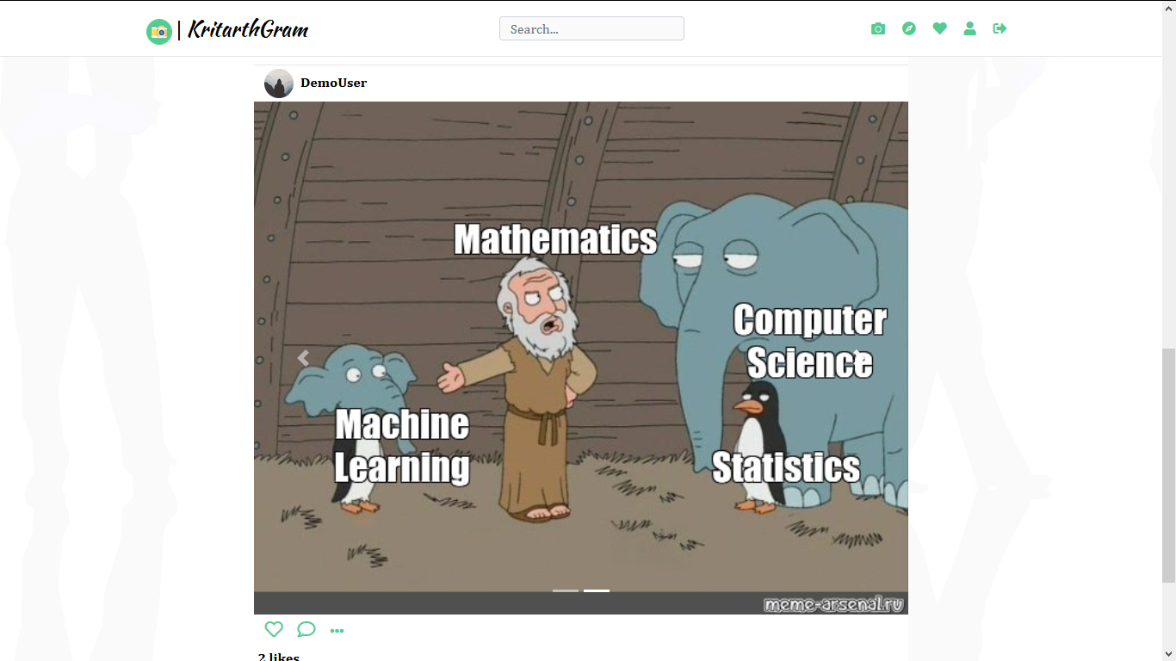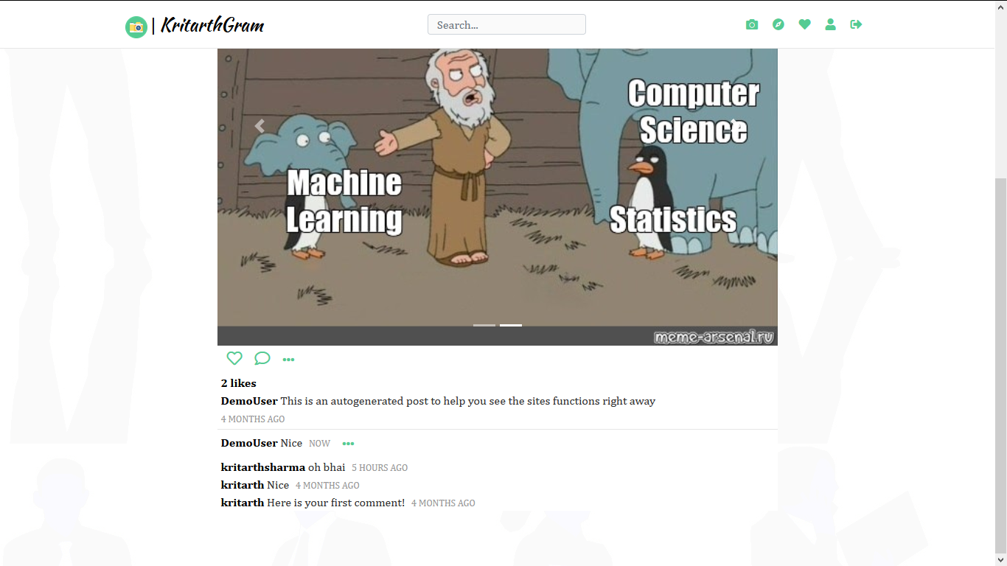

**4)Like**

Users can like on the post,without refreshing of the page the like is stored instantaneously using ajax request.

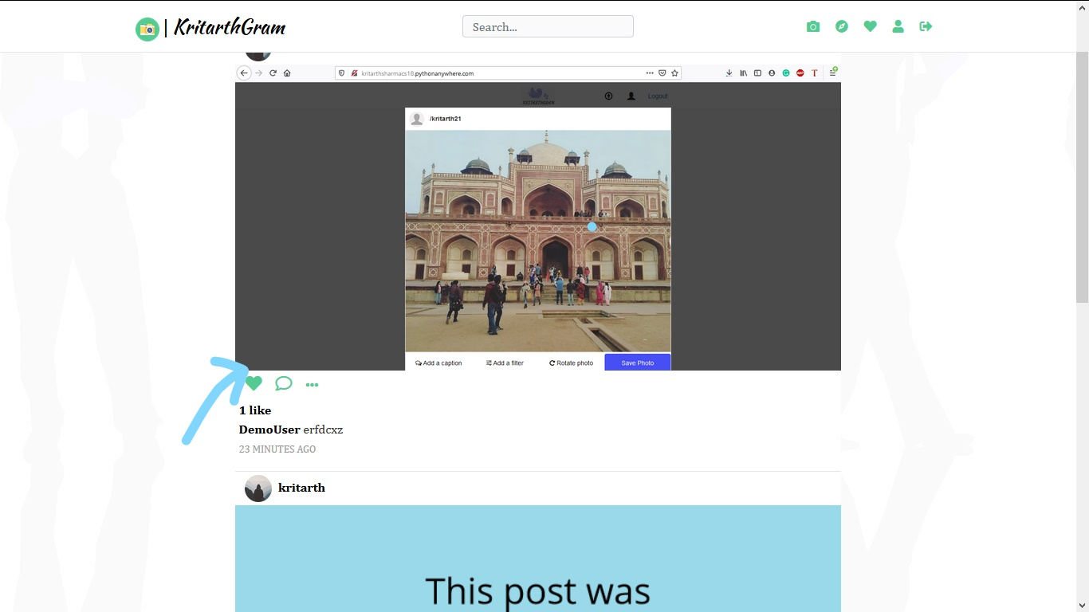

**5)Comment**

Users can comment any no of time on any post

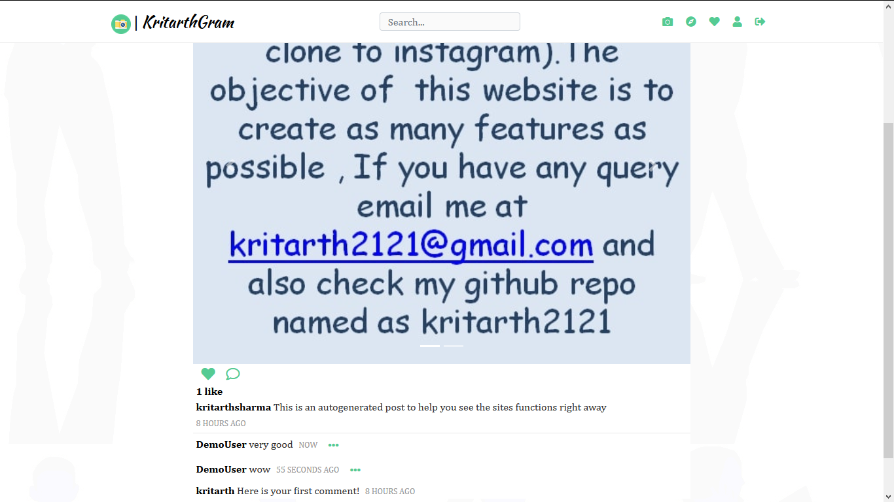

**6)Search**

We can search for any text present in any username,any post.

The search results are then fetched in list order.

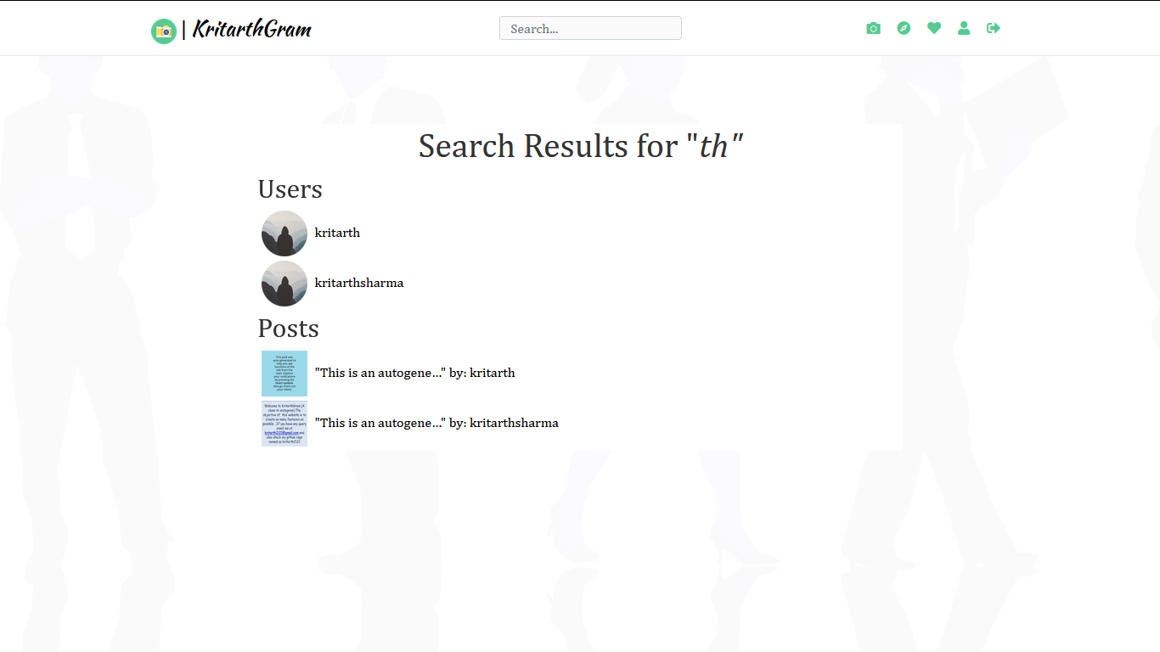

**7)Explore**

There is a feature of exploring newly made accounts,newly made posts

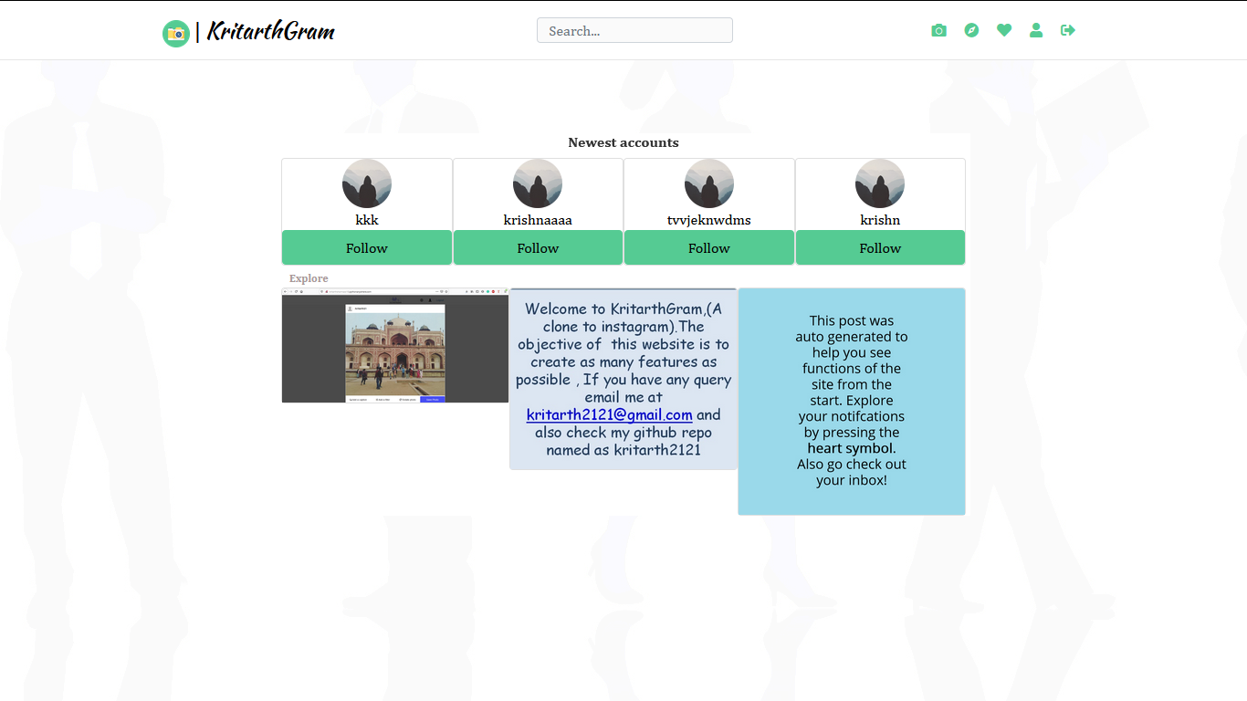

**8)Notification**

Here user can view who have liked ,commented or followed them.

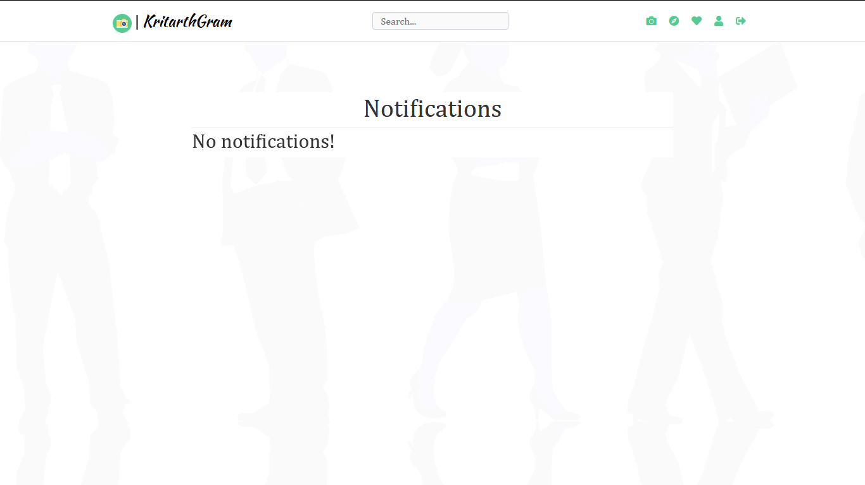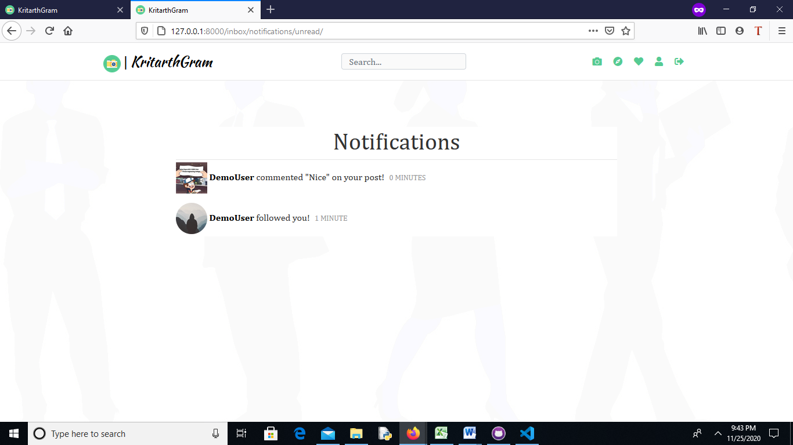

**9)Profile view.**

Users can see their followers ,following list,photos,.They can also edit their profile picture and update and delete any posts.

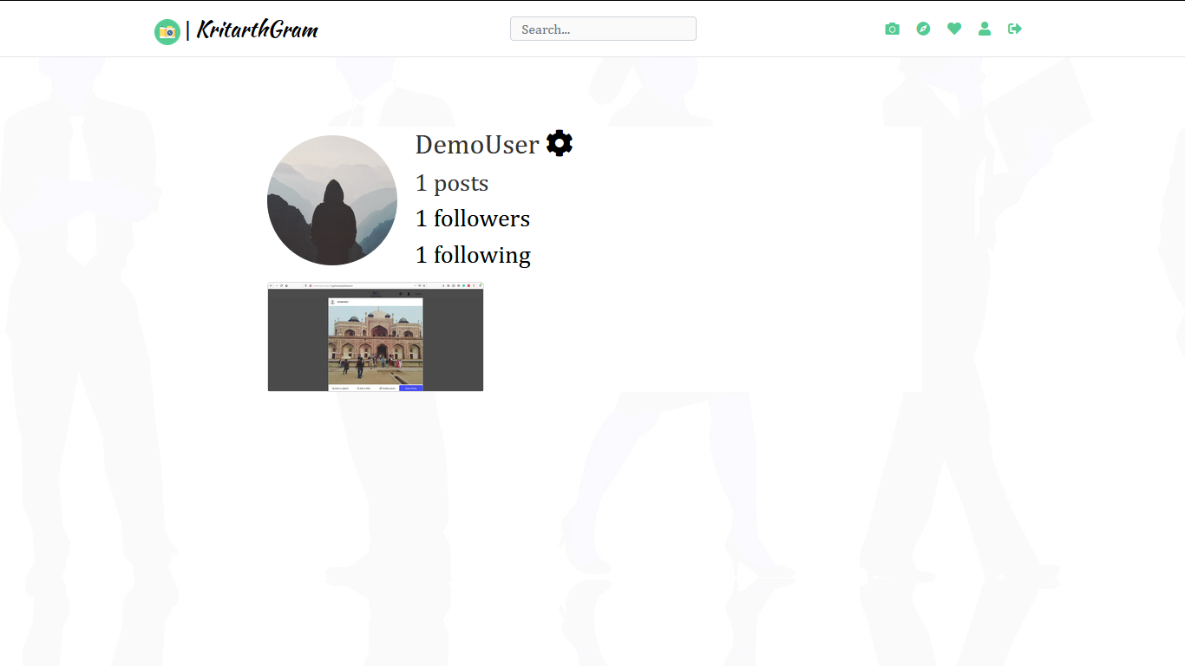

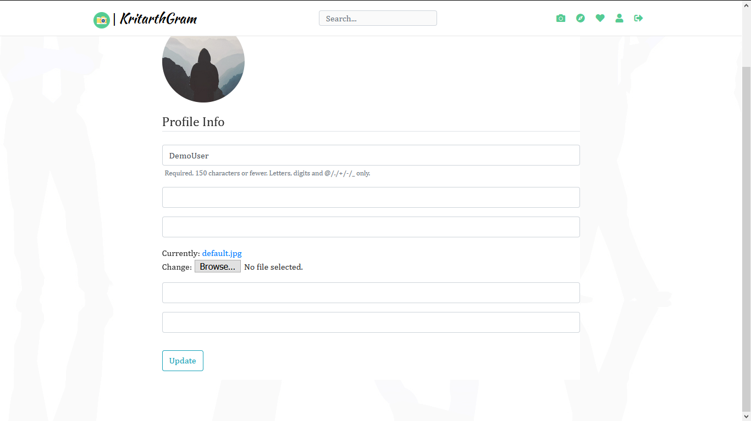

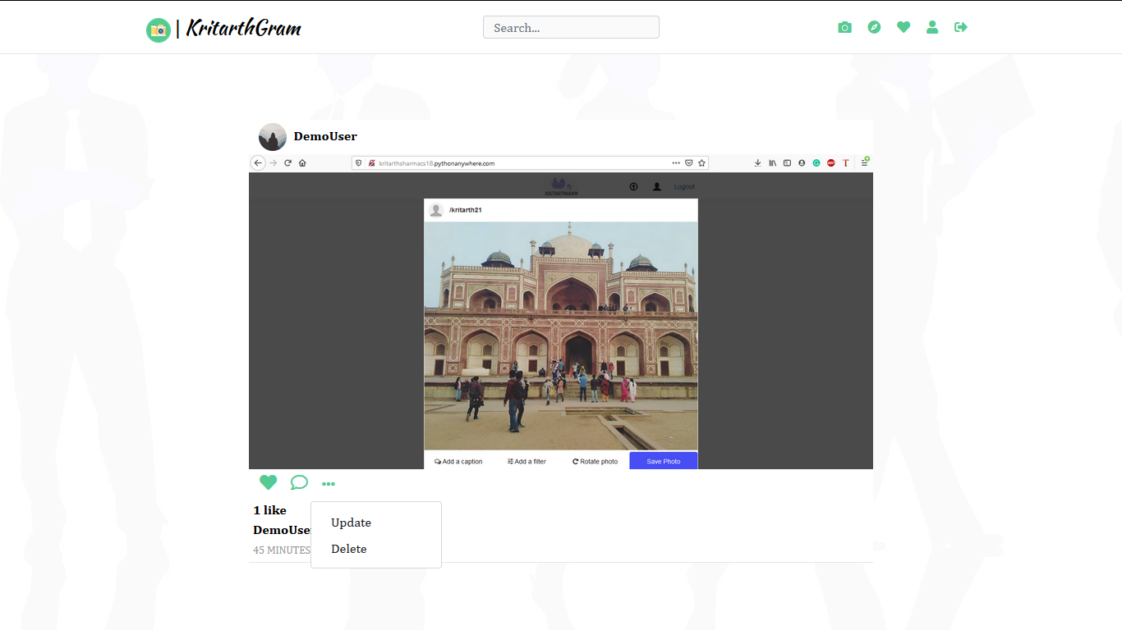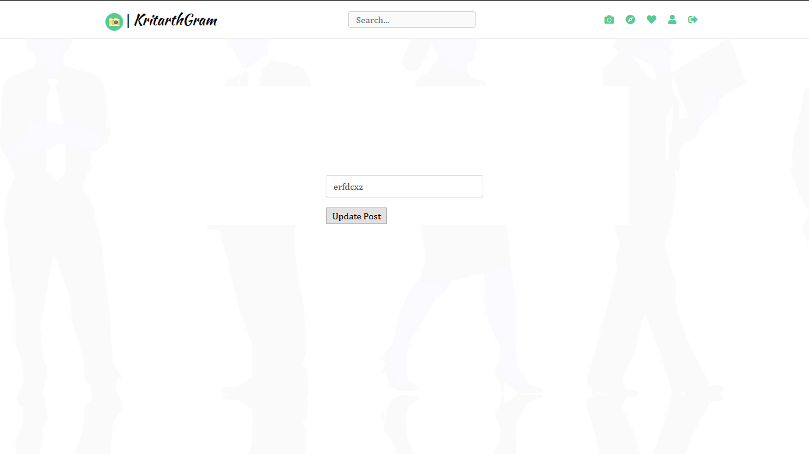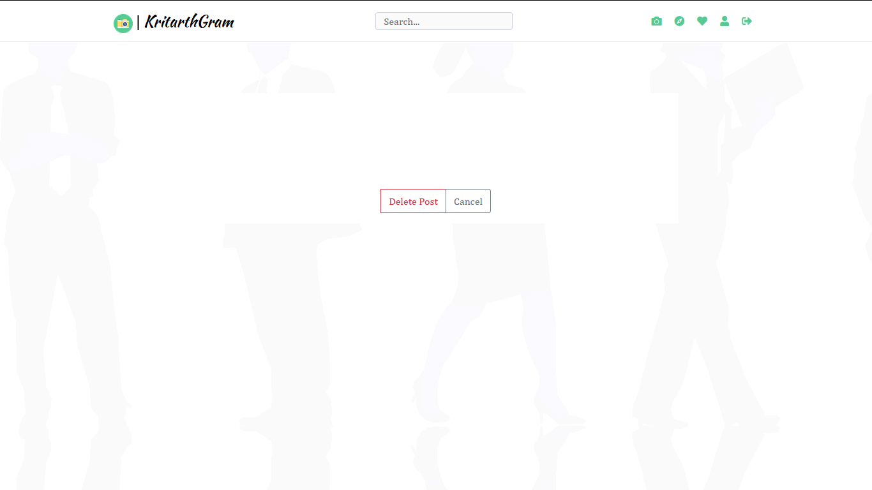

**10)Adding posts**

We can add post along with caption,we can add 4 photos at a time.

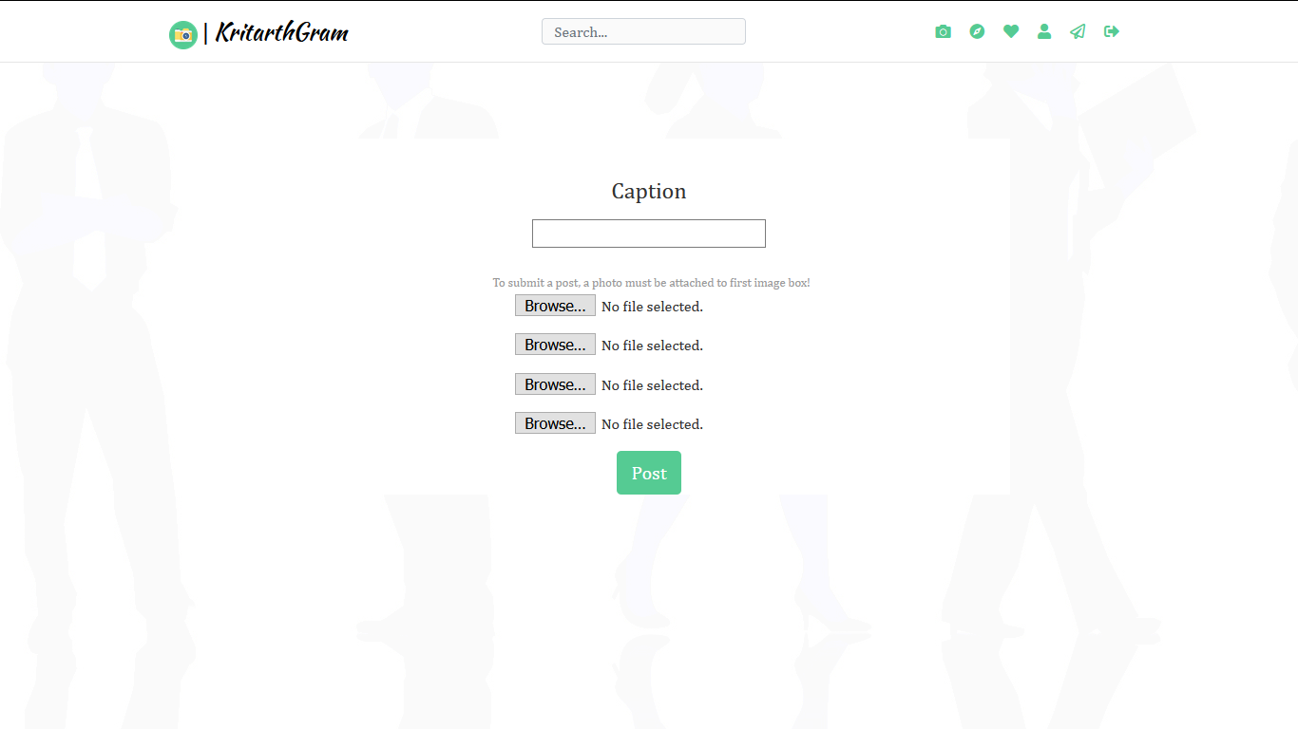

**11)Logout**

Users can logout from their account simply by clicking on the logout icon present on the corner of page.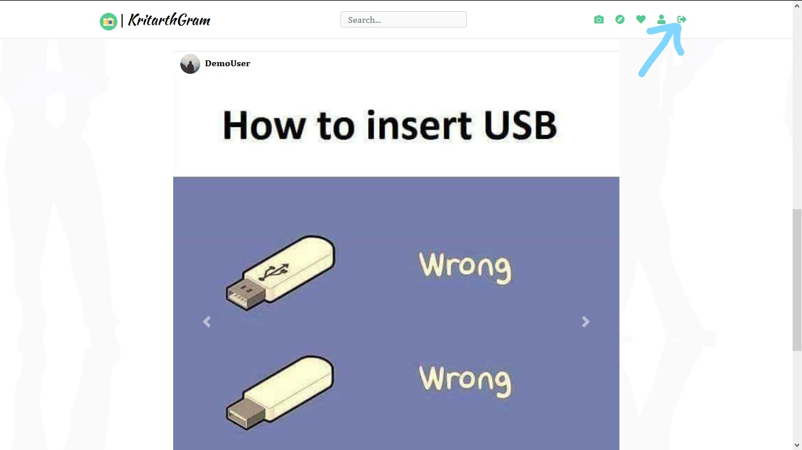

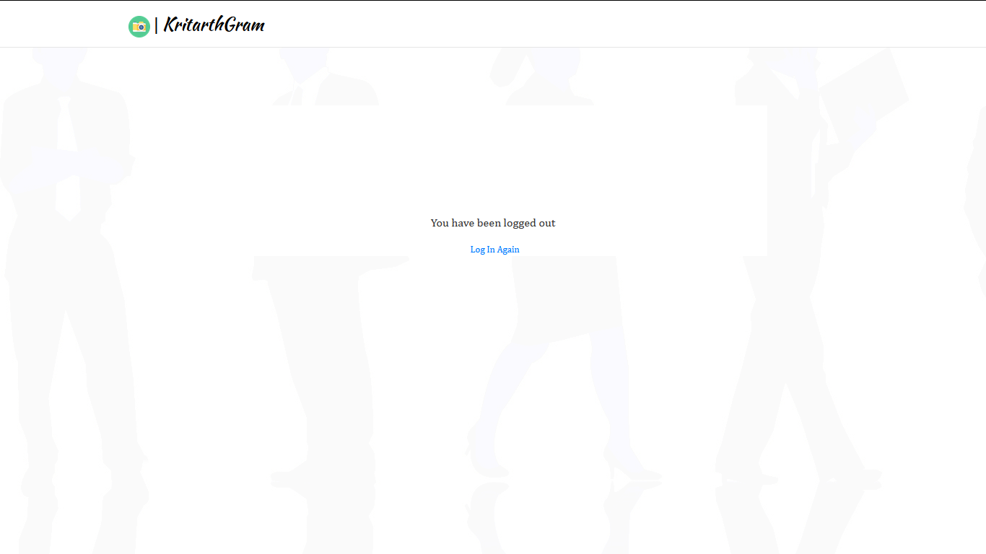

**12)Amazon s3 for storage**

We have used amazon s3 for storing media.

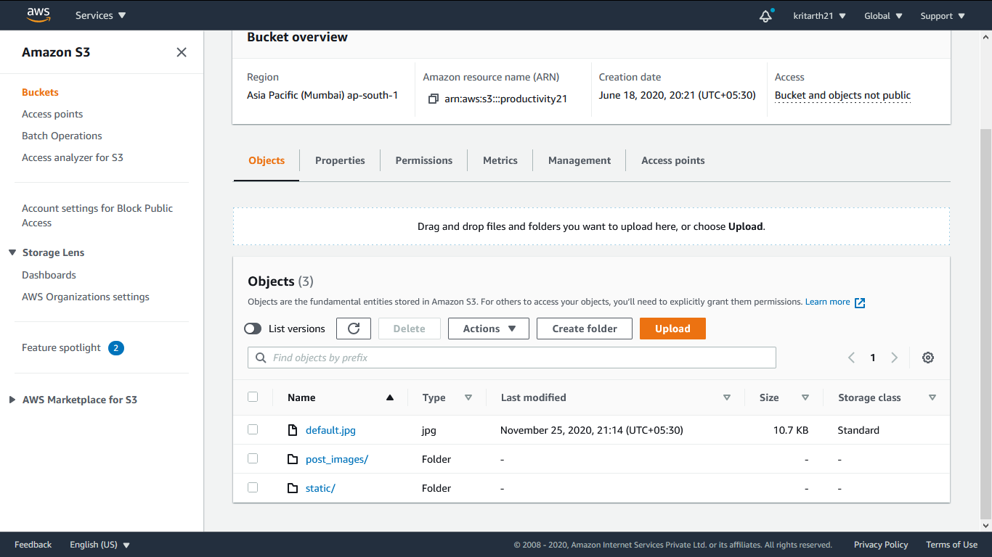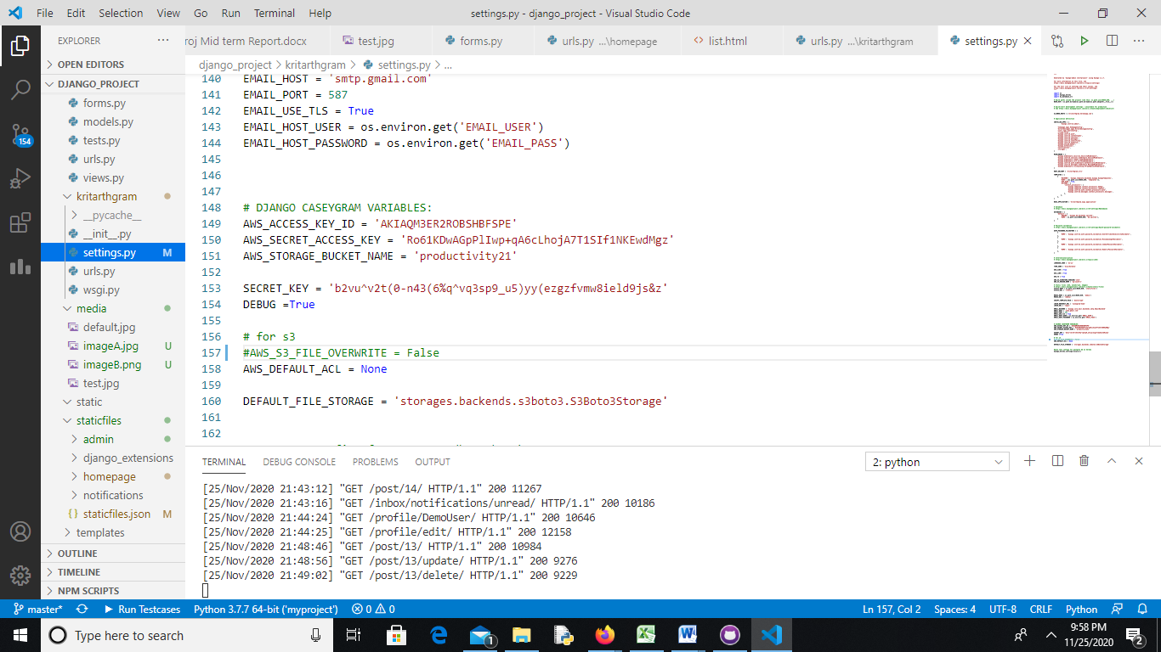

**13)Responsiveness**

We have made it fully respnsive

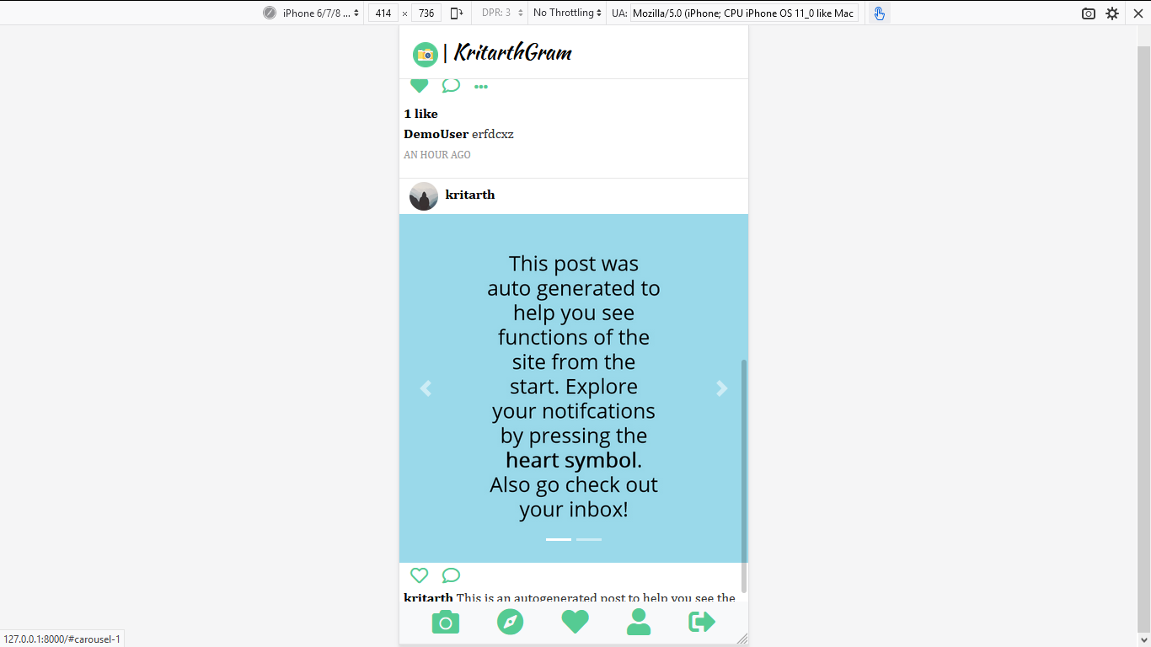

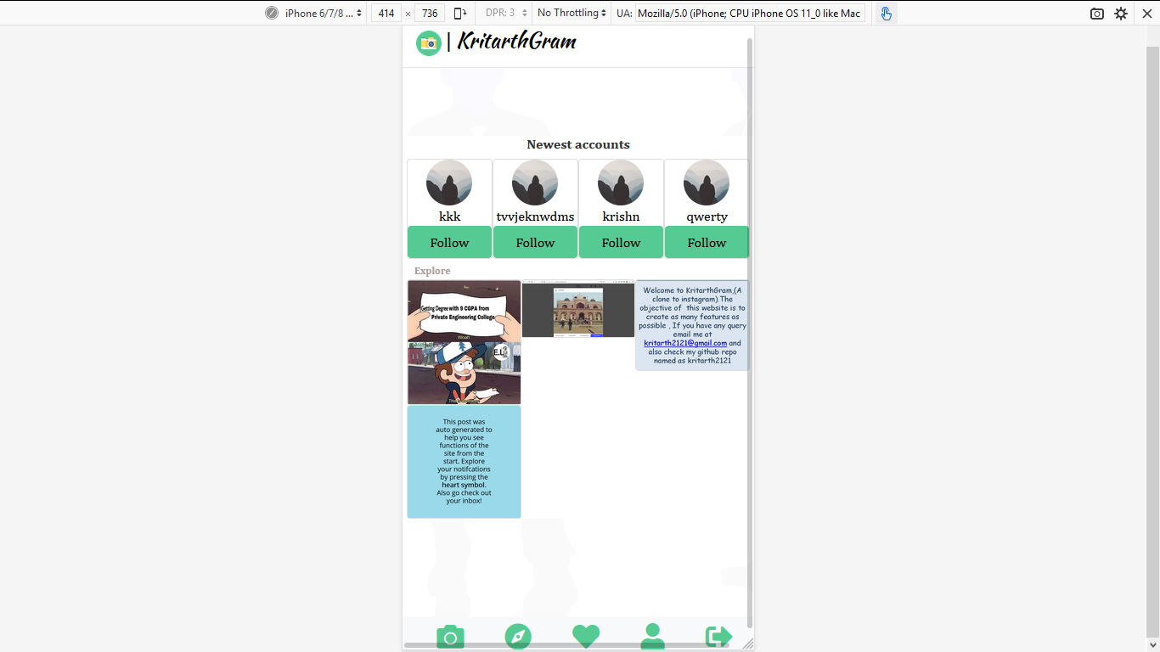

**14)Database**

We have used django default database sqllite,as datbase

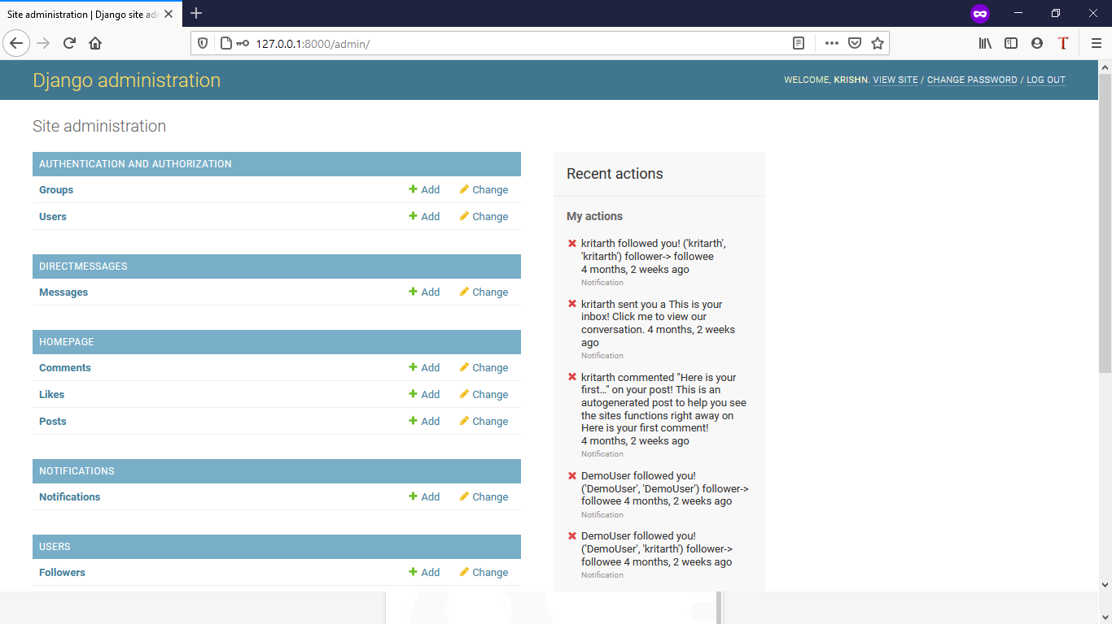

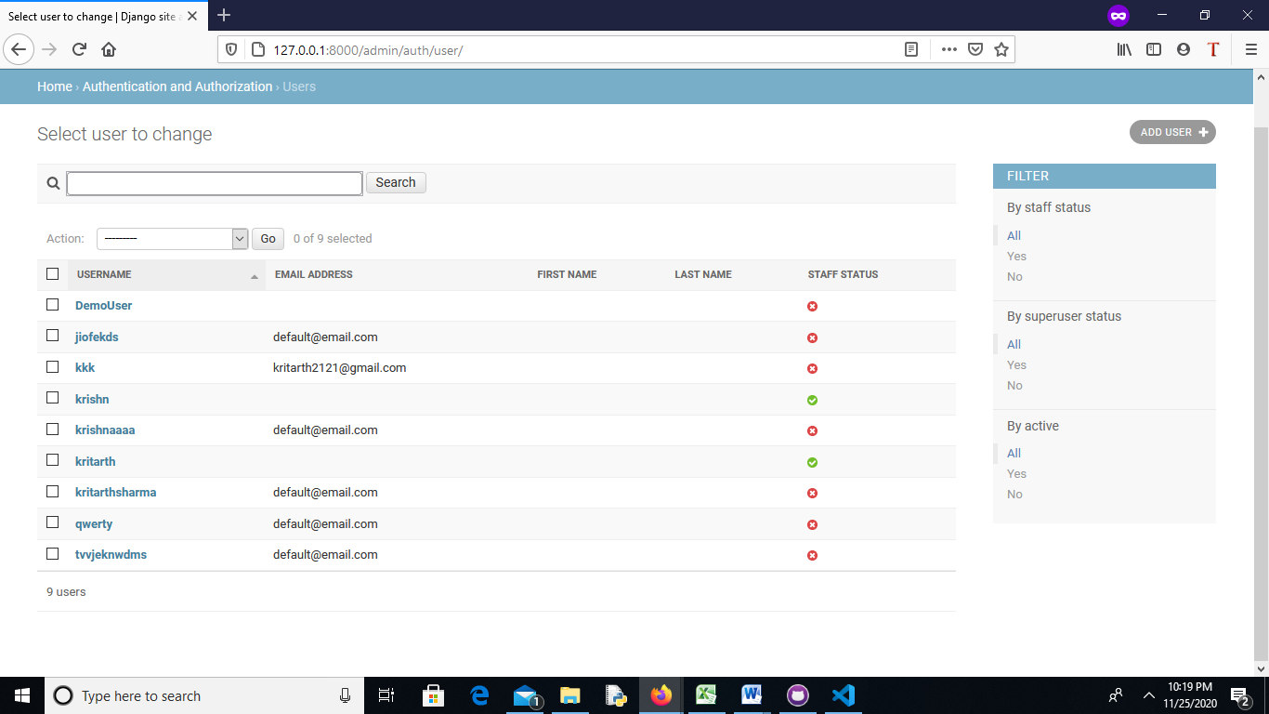

# Objective

The main objectives of Social networking project is to make people connected as much as possible.

Here people can upload photos or videos to our service and share them with their followers or with a select group of friends. They can also view, comment and like posts shared by their friends on **Kritarthgram**.

As social networking sites are gaining popularity day by day,so we try to build it using Django,Ajax,HTML,CSS,Javascript,Amazon s3

It is an Indian based web-app hosted on Heroku.

**Software Specification:**

Technology Implemented : Django

Language Used : Python

Database : Mysql

User Interface Design : Html,css , javascript and Bootstrap

Web Browser : Microsoft edge/chrome

**Hardware Requirements:**

Processor : 64-bit

Operating System : Any one (Preferrrably above Windows 8)

RAM : 4-GB

**Technology Used**

**HTML**

**Hypertext Markup Language** (**HTML**) is the standard [markup language](https://en.wikipedia.org/wiki/Markup_language) for documents designed to be displayed in a [web browser](https://en.wikipedia.org/wiki/Web_browser). It can be assisted by technologies such as [Cascading Style Sheets](https://en.wikipedia.org/wiki/Cascading_Style_Sheets) (CSS) and [scripting languages](https://en.wikipedia.org/wiki/Scripting_language) such as [JavaScript](https://en.wikipedia.org/wiki/JavaScript).

[Web browsers](https://en.wikipedia.org/wiki/Web_browser) receive HTML documents from a [web server](https://en.wikipedia.org/wiki/Web_server) or from local storage and [render](https://en.wikipedia.org/wiki/Browser_engine) the documents into multimedia web pages. HTML describes the structure of a [web page](https://en.wikipedia.org/wiki/Web_page) [semantically](https://en.wikipedia.org/wiki/Semantic_Web) and originally included cues for the appearance of the document.

[HTML elements](https://en.wikipedia.org/wiki/HTML_element) are the building blocks of HTML pages. With HTML constructs, [images](https://en.wikipedia.org/wiki/HTML_element#Images_and_objects) and other objects such as [interactive forms](https://en.wikipedia.org/wiki/Fieldset) may be embedded into the rendered page. HTML provides a means to create [structured documents](https://en.wikipedia.org/wiki/Structured_document) by denoting structural [semantics](https://en.wikipedia.org/wiki/Semantics) for text such as headings, paragraphs, lists, [links](https://en.wikipedia.org/wiki/Hyperlink), quotes and other items. HTML elements are delineated by *tags*, written using [angle brackets](https://en.wikipedia.org/wiki/Bracket#Angle_brackets). Tags such as <img /> and <input /> directly introduce content into the page. Other tags such as <p> surround and provide information about document text and may include other tags as sub-elements. Browsers do not display the HTML tags, but use them to interpret the content of the page.

HTML can embed programs written in a [scripting language](https://en.wikipedia.org/wiki/Scripting_language) such as [JavaScript](https://en.wikipedia.org/wiki/JavaScript), which affects the behavior and content of web pages. Inclusion of CSS defines the look and layout of content. The [World Wide Web Consortium](https://en.wikipedia.org/wiki/World_Wide_Web_Consortium) (W3C), former maintainer of the HTML and current maintainer of the CSS standards, has encouraged the use of CSS over explicit presentational HTML since 1997